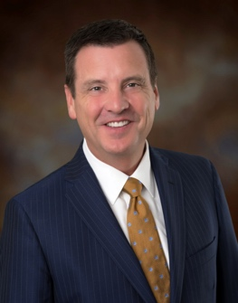 Bill Sublette

AN ATTORNEY BY PROFESSION, BILL SUBLETTE earned his law and bachelor degrees from the University of Florida. After graduating from law school in 1988 he moved to Orlando, and in 1992 he won a seat in the Florida House of Representatives, where he served for eight years. During his time in the Legislature he filled a variety of leadership positions, including stints as Chairman of the Education Appropriations Committee, Chairman of the House Public Responsibility Council, and Chairman of the Orange County Legislative Delegation.

Since leaving the Legislature, Bill has served as Chairman of the Orange County Jail Oversight Commission, and he has led, as President or Chair, a number of community organizations, including public broadcaster WMFE, the Orange County Bar Association, the local American Cancer Society, and the Central Florida Council of the Boy Scouts of America. Bill has also been a tireless advocate for children’s issues. Locally he has served as a Guardian ad Litem for over 60 children, and has chaired, the Howard Phillips Center for Children and Families Community Advisory Board. He has also served as the statewide chair of the Children’s Campaign 5 Promises to Children initiative, as co-chair of the statewide Trust the Voters campaign with Senator Bob Graham, and sat on the Governor’s Blueprint Commission for Juvenile Justice.

Throughout his career Bill has worked to improve the quality of our public schools. He served as President of the Blankner School Foundation and School Advisory Committee. In 2003, Mayor Dyer and the City of Orlando called on him to serve as Chair of the Mayor’s Education Action Council, and in 2004 he was asked by Mayor Crotty, Mayor Dyer and the Orange County School Board to Chair the Blue Ribbon Panel on Education, a group of 25 community leaders charged with studying the Orange County Public School system and making recommendations for the improvement of our public school system. In 2010 he became Florida’s first countywide elected Chair of a local school board, the Orange County School Board, a position he served in until 2018.

Bill and his wife Suzie are the proud parents of three children: Alex, Aubrey, and Jack.

